Chapter 16, Problem 13.

Using Fig. 16.36, design a problem to help other students better understand circuit analysis using Laplace transforms.

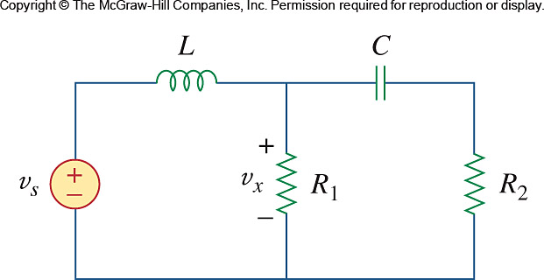

Figure 16.36
For Prob. 16.13.

